Review Table 1 Performance comparison across different LLMs in estimating Chinese word familiarity.
Word length | Model | N | Pearson r | MAE | Spearman ρ | Kendall τ
1 | GPT-4o (expression) | 2,336 | .62 | 1.29 | .63 | .46
 | Qwen-max | 2,355 | .58 | 0.69 | .60 | .44
2 | GPT-4o (word) | 20,226 | .58 | 1.12 | .59 | .41
 | Qwen-max | 20,275 | .52 | 0.68 | .54 | .39
3 | GPT-4o (word) | 1,223 | .61 | 0.80 | .61 | .44
 | Qwen-max | 1,231 | .59 | 0.71 | .62 | .45
4 | GPT-4o (expression) | 2,815 | .57 | 0.70 | .53 | .37
 | Qwen-max | 2,819 | .49 | 0.67 | .50 | .35
Note. All p-values are less than 0.001.

Review Table 2 Historical frequency trends of words in Table 3 by Google Ngram
Word | SUBTLEX-CH WF Rank | Historical frequency trends
昨 | Top 40–50% | 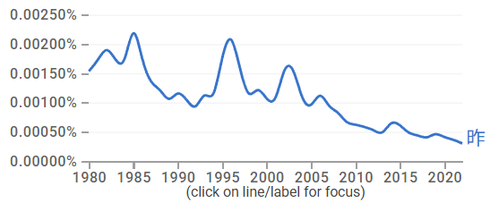
裤 | Top 0–10% | 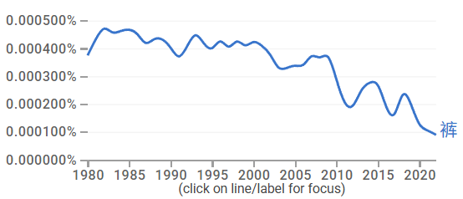
禾 | Top 60–70% | 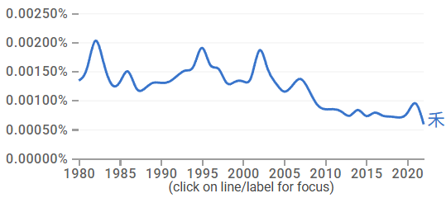
泥 | Top 0–10% | 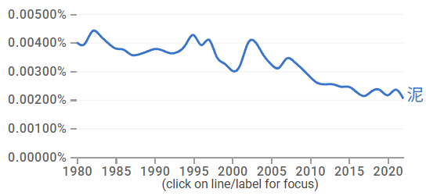
叨 | Top 20–30% | 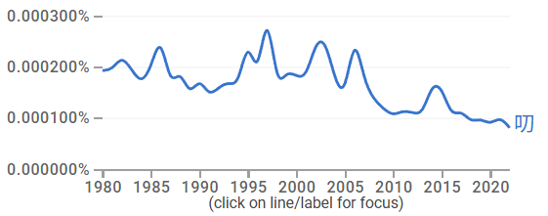
空乏 | – | 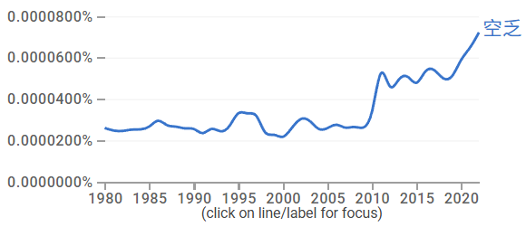
枯朽 | – | 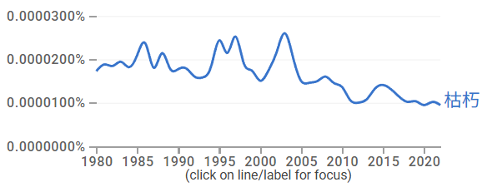
分辩 | Top 60–70% | 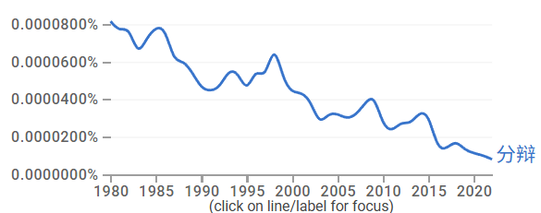
暗想 | Top 60–70% | 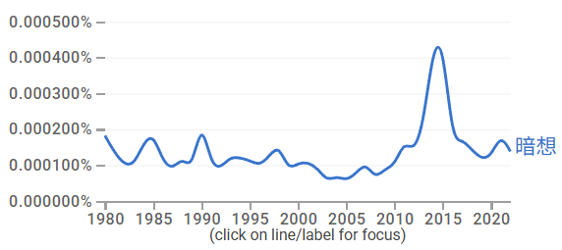
良多 | Top 30–40% | 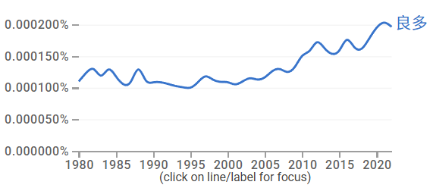
打寒噤 | - | 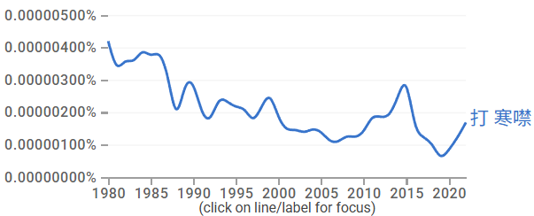
死胡同 | Top 10–20% | 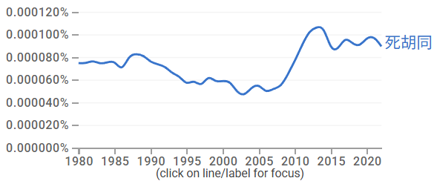
漂亮话 | Top 40–50% | 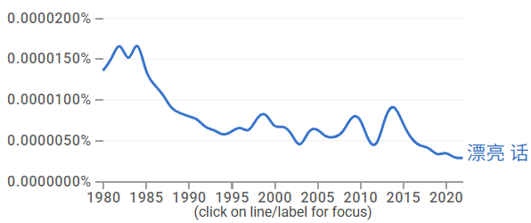
迷魂药 | Top 60–70% | 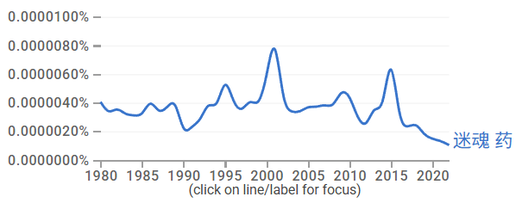
扩音器 | Top 20–30% | 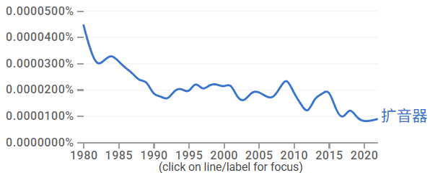
闭路电视 | Top 20–30% | 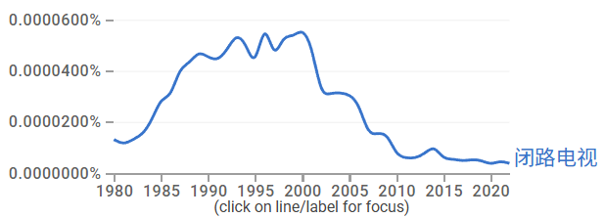
有始无终 | Top 80-90% | 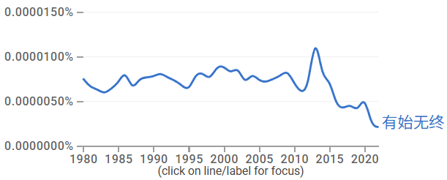
浑浑噩噩 | Top 40–50% | 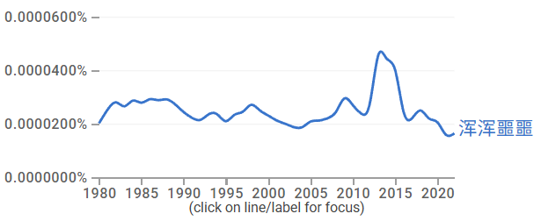
出将人相 | – | 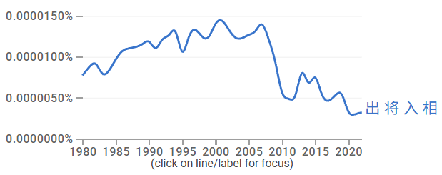
损公肥私 | – | 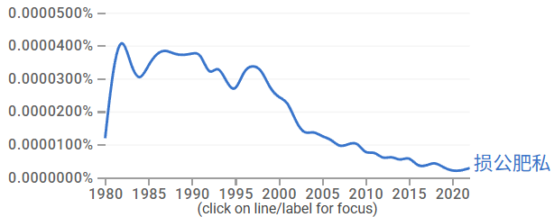

Review Table 3 Multiple regression predicting LLM familiarity estimates of three-character words from that of their constituents
Model | GPT-4o (N = 153) |  |  |  | Qwen-max (N = 188)
 | β | SE | t | p | β | SE | t | p
Character
C1 (1) | -.020 | .075 | -.261 | .794 | .056 | .065 | .862 | .390
C2 (2) | .210 | .075 | 2.809 | .006 | .182 | .062 | 2.957 | .004
C3 (3) | .158 | .075 | 2.127 | .035 | .115 | .061 | 1.900 | .059
Bigrams
B1 (1+2) | .319 | .075 | 4.234 | <.001 | .483 | .065 | 7.417 | <.001
 | R² = .181, F(4, 148)=8.20, p<.001. |  |  |  | R² = .330, F(4, 183)=22.56, p<.001.

Review Table 4 Multiple regression predicting LLM familiarity estimates of four-character words from that of their constituents
Model | GPT-4o (N = 147) |  |  |  | Qwen-max (N = 195)
 | β | SE | t | p | β | SE | t | p
Character
C1 (1) | .049 | .082 | .600 | .550 | .329 | .068 | 4.853 | <.001
C2 (2) | .029 | .083 | .347 | .729 | .064 | .068 | .940 | .348
C3 (3) | .042 | .083 | .509 | .612 | .082 | .068 | 1.211 | .227
C4 (4) | .209 | .083 | 2.524 | .013 | .155 | .068 | 2.261 | .025
 | R² = .051, F(4,142) = 1.92, p=.111. |  |  |  | R² = .144, F(4,190) =7.99, p < .001.

